**Configuration of Static Routing.**

**Intended Learning Outcome:**a. Set up of several routers and configure them for data sends among them .  
b. Decide the best path using static routing.  
c. Create static routing networks.

**Expected skills:**a. Router and end device Configuration.  
b. Connecting different networks with static routing.

c. Basic knowledge about clock rate and bandwidth.

**Tools Required:**a. Packet Tracer.  
  
**Session Detail:**

Step 1: Start CISCO PACKET.

Step 2: Create a topology.

[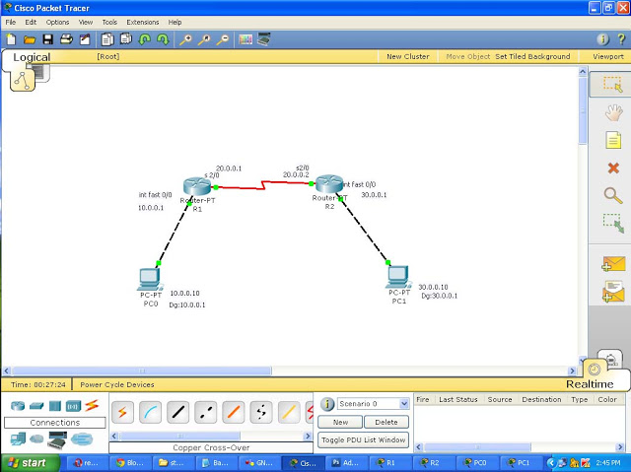](http://2.bp.blogspot.com/-6IGN2NIKm78/UQJOvHxm0gI/AAAAAAAAABE/QcteWUOFwWI/s1600/f.jpg)

Step 3: Configure ip address to routers go to global configuration mode in R1 and R2 configure connected interfaces.

Step 4: Assign ip address for both Pc's with appropriate ip and subnetmask and default gateway.

Step 5: Now configure both router with static route.

**R1(config)#ip route Destination Network| Destination N/W SubnetMask |Next Hop Address**

Step 5: Double click PC move to desktop then command prompt give the command ping from one PC to another to test the connection.

**Post Lab Exercise: Configure the following topology with static routing.**

